Module 7. Exception handling

What happens when an exception is thrown?

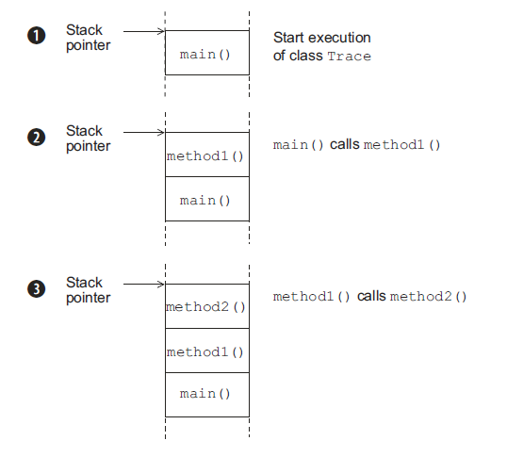
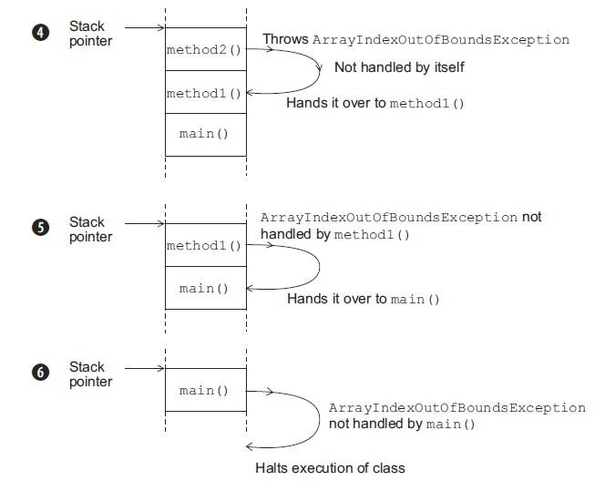

Figure. Propagation of an exception through multiple method calls

Categories of exceptions

Identifying exception categories

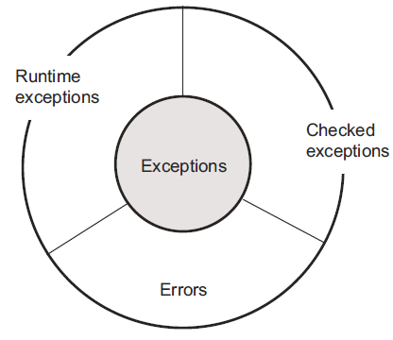
Figure. Categories of exceptions: checked exceptions, runtime exceptions, and errors

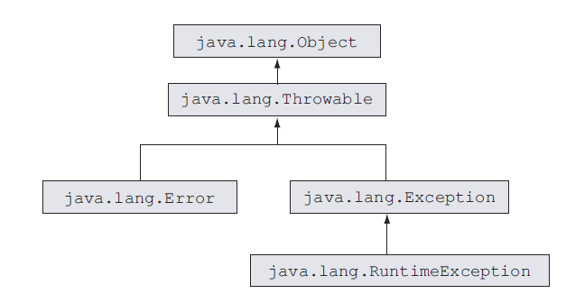
Figure. Class hierarchy of exception categories

Common exception classes and categories

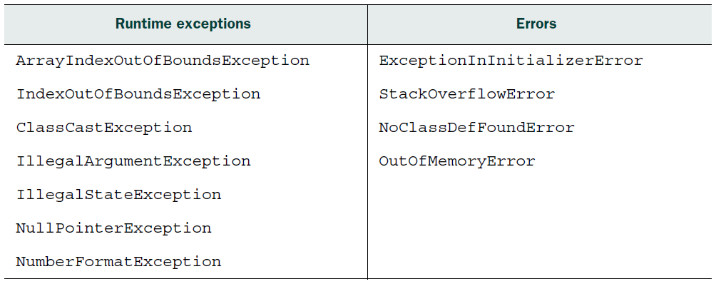

Table. Common errors and exceptions

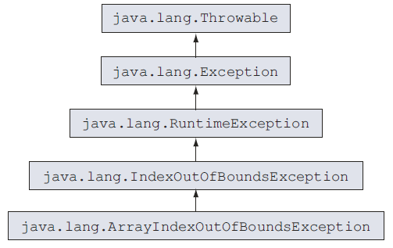

Figure. Class hierarchy of ArrayIndexOutOfBoundsException

Review notes

A taste of exceptions:
■ Trying to access an array element at a position that is greater than or equal to the array’s length is considered an exceptional condition.
■ Trying to execute a method that throws a checked exception without handling the thrown exception causes a compilation error.
■ Trying to call a method recursively without defining an exit condition is considered an exceptional condition.
■ Proper handling of exceptions is important in Java. It enables a programmer to define alternative code to execute in case an exceptional condition is met.

Why handle exceptions separately:
■ Exception handlers refer to the blocks of code that execute when an exceptional condition arises during code execution.
■ Handling exceptions separately enables you to define the main logic of your code together.
■ Without the use of separate exception handlers, the main logic of your code would be lost in combating the exceptional conditions.
■ Separate exception handlers enable you to define alternative code to execute separately from your main code flow when an exceptional condition is met.
■ Exception handlers separate the concerns of defining the regular program logic from exception-handling code.
■ Exceptions also help pinpoint the offending code, together with the method in which it is defined, by providing a stack trace of the exception or error.
■ The stack trace of an exception enables you to get a list of all the exceptions that executed before the exception was reported.
■ The stack trace of an exception is available within an exception handler.
■ The JVM may send the stack trace of an unhandled exception to the Java console.

An exception is thrown:
■ An exception is an object of the class java.lang.Throwable.
■ When a piece of code hits an obstacle in the form of an exceptional condition, it creates an object of subclass java.lang.Throwable, initializes it with the necessary information (such as its type and optionally a textual description and the offending program’s state), and hands it over to the JVM.
■ The JVM keeps an account of all the methods that were called when it hits the code that throws an exception. To find an appropriate exception handler, it looks through all these method calls.
■ Enclose the code that may throw an exception within a try block.
■ Define catch blocks to include alternative code to execute when an exceptional condition arises.
■ A try block can be followed by one or more catch blocks.
■ The catch blocks must be followed by zero or one finally block.
■ The finally block executes regardless of whether the code in the try block
throws an exception.
■ A try block can’t define multiple finally blocks.
■ The order in which the catch blocks are placed matters. If the caught exceptions have an inheritance relationship, the base class exceptions can’t be caught before the derived class exceptions. An attempt to do this will result in compilation Failure.
■ A finally block will execute even if a try or catch block defines a return
statement.
■ A try block may be followed by either a catch or a finally block or both.
■ If both catch and finally blocks define return statements, the calling method will receive the value from the finally block.
■ If a catch block returns a primitive data type, a finally block can’t modify the value being returned by it.
■ If a catch block returns an object, a finally block can modify the value being returned by it.
■ A finally block alone wouldn’t suffice with a try block if code in the try
block throws a checked exception. In this case, you need to catch the checked exception or define in the method signature that the exception is thrown, or your code won’t compile.
■ None of the try, catch, and finally blocks can exist independently.
■ The finally block can’t appear before a catch block.
■ You can rethrow an error that you catch in an exception handler.
■ You can either handle an exception or declare it to be thrown by your method. In the latter case, you need not handle the exception in your code. This applies to checked exceptions.
■ You can create nested exception handlers.
■ A try, catch, or finally block can define another try-catch-finally block.
Theoretically, there is no limit on the allowed level of nesting of try-catchfinally Blocks.

Categories of exceptions:
■ Exceptions are divided into three categories: checked exceptions, runtime (or unchecked exceptions), and errors. These three categories share IS-A relationships (inheritance).
■ Subclasses of the class java.lang.RuntimeException are categorized as runtime exceptions.
■ Subclasses of the class java.lang.Error are categorized as errors.
■ Subclasses of the class java.lang.Exception are categorized as checked exceptions if they are not subclasses of class java.lang.Runtime.
■ The class java.lang.RuntimeException is a subclass of the class java.lang
.Exception.
■ The class java.lang.Exception is a subclass of the class java.lang.Throwable.
■ The class java.lang.Error is also a subclass of the class java.lang.Throwable.
■ The class java.lang.Throwable inherits the class java.lang.Object.

Checked exceptions:
■ A checked exception is an unacceptable condition foreseen by the author of a method, but outside the immediate control of the code.
■ FileNotFoundException is a checked exception. This exception is thrown if the file that the code is trying to access can’t be found.
■ All checked exceptions are a subclass of the java.lang.Exception class, not a subclass of java.lang.RuntimeException. It’s interesting to note, however,
that the class java.lang.RuntimeException itself is a subclass of the class
java.lang.Exception.
■ If a method calls another method that may throw a checked exception, either it must be enclosed within a try-catch block or the method should declare this exception to be thrown in its method signature.

Runtime exceptions:
■ Runtime exceptions represent programming errors. These occur from inappropriate use of another piece of code. For example, NullPointerException is a runtime exception that occurs when a piece of code tries to execute some code on a variable that hasn’t been assigned an object and points to null. Another example is ArrayIndexOutOfBoundsException, which is thrown when a piece of
code tries to access an array of list elements at a nonexistent position.
■ A runtime exception is a subclass of java.lang.RuntimeException.
■ A runtime exception isn’t a part of the method signature, even if a method may throw it.
■ A runtime exception may not necessarily be caught by a try-catch block.

Errors:
■ An error is a serious exception, thrown by the JVM as a result of an error in the environment state, which processes your code. For example, NoClassDefFoundError is an error thrown by the JVM when it is unable to locate the .class file it is supposed to run.
■ StackOverflowError is another error, thrown by the JVM when the size of the memory required by the stack of the Java program is greater than what the JRE has offered for the Java application. This error usually occurs as a result of infinite or highly nested loops.
■ An error is a subclass of the class java.lang.Error.
■ An error need not be a part of a method signature.
■ Though you can handle the errors syntactically, there is little that you can do when these errors occur. For example, when the JVM throws OutOfMemoryError, your code execution will halt, even if you define an exception handler for it.

Commonly occurring exceptions, categories, and classes:
■ ArrayIndexOutOfBoundsException is a runtime exception that’s thrown when a piece of code tries to access an array position out of its bounds—when an array is accessed either at a position less than 0 or at a position greater than or equal to its length.
■ IndexOutOfBoundsException is a runtime exception that’s thrown when a piece of code tries to access a list position that’s out of its bounds—when the position is either less than 0 or greater than or equal to the list’s size.
■ The class ArrayIndexOutOfBoundsException extends the class java.lang.IndexOutOfBoundsException, which extends the class java.lang.RuntimeException.
■ In typical programming conditions, the ArrayIndexOutOfBoundsException shouldn’t be thrown programmatically.
■ One of the main reasons for the JVM taking the responsibility for throwing this exception itself is that this exception isn’t known until runtime and depends on the array or list position that’s being accessed by a piece of code. Most often, a variable is used to specify this array or list position, and its value may not be known until runtime.
■ ClassCastException is a runtime exception. java.lang.ClassCastException
extends java.lang.RuntimeException.
■ ClassCastException is thrown when an object fails an IS-A test with the class type it is being cast to.
■ You can use the operator instanceof to verify whether an object can be cast to another class before casting it.
■ IllegalArgumentException is a runtime exception. java.lang.Illegal-
ArgumentException extends java.lang.RuntimeException.
■ IllegalArgumentException is thrown to specify that a method has been passed illegal or inappropriate arguments.
■ Even though IllegalArgumentException is a runtime exception, programmers usually use this exception to validate the arguments that are passed to a method, and the exception constructor is passed a descriptive message specifying the exception details.
■ IllegalStateException is a runtime exception. java.lang.IllegalState-
Exception extends java.lang.RuntimeException.
■ IllegalStateException may be thrown programmatically.
■ As a programmer, you can throw IllegalStateException to signal to the calling method that the method that’s being requested for execution isn’t ready to start its execution or is in a state in which it can’t execute.
■ For example, you can throw IllegalStateException from your code if an
application tries to modify an SMS that has already been sent.
■ NullPointerException is a runtime exception. The class java.lang.Null-
PointerException extends java.lang.RuntimeException.
■ NullPointerException is thrown by the JVM if you try to access a method or variable of an uninitialized reference variable.
■ NumberFormatException is a runtime exception. java.lang.NumberFormatException extends java.lang.IllegalArgumentException. java.lang.Illegal-
ArgumentException extends java.lang.RuntimeException.
■ You can throw NumberFormatException from your own method to indicate that there’s an issue with the conversion of a String value to a specified numeric format (decimal, octal, hexadecimal, or binary).
■ Runtime exceptions arising from any of the following may throw ExceptionInInitializerError:
– Execution of an anonymous static block
– Initialization of a static variable
– Execution of a static method (called from either of the previous two items)
■ The error ExceptionInInitializerError can be thrown only by an object of a
runtime exception.
■ ExceptionInInitializerError can’t be thrown if a static initializer block
throws an object of a checked exception, because the Java compiler is intelligent enough to determine this condition and it doesn’t allow you to throw an unhandled checked exception from a static initialization block.
■ StackOverflowError is an error. java.lang.StackOverflowError extends
java.lang.VirtualMachineError.
■ Because StackOverflowError extends VirtualMachineError, it should be left to be managed by the JVM.
■ The StackOverflowError error is thrown by the JVM when a Java program calls itself so many times that the memory stack allocated to execute the Java program “overflows.”
■ NoClassDefFoundError is an Error. java.lang.NoClassDefFoundError extends java.lang.LinkageError. java.lang.LinkageError extends java.lang.Error.
■ NoClassDefFoundError is thrown by the JVM or a ClassLoader when it is
unable to load the definition of a class required to create an object of the class.
■ Don’t confuse the exception thrown by Class.forName(), used to load the
class, and NoClassDefFoundError thrown by the JVM. Class.forName() throws ClassNotFoundException.
■ OutOfMemoryError is thrown by the JVM when it’s unable to create objects on the heap and the garbage collector may not be able to free more memory for the JVM.

Sample questions

Q7-1. What is the output of the following code:
class Course {
String courseName;
Course() {
Course c = new Course();
c.courseName = "Oracle";
}
}
class EJavaGuruPrivate2 {
public static void main(String args[]) {
Course c = new Course();
c.courseName = "Java";
System.out.println(c.courseName);
}
}
a The code will print Java.
b The code will print Oracle.
c The code will not compile.
d The code will throw an exception or an error at runtime.

Q7-2. Select the correct option(s):
a You cannot handle runtime exceptions.
b You should not handle errors.
c If a method throws a checked exception, it must be either handled by the
method or specified in its throws clause.
d If a method throws a runtime exception, it may include the exception in its throws clause.
e Runtime exceptions are checked exceptions.

Q7-3. Examine the following code and select the correct option(s):
class EJavaGuruExcep2 {
public static void main(String args[]) {
EJavaGuruExcep2 var = new EJavaGuruExcep2();
var.printArrValues(args);
}
void printArrValues(String[] arr) {
try {
System.out.println(arr[0] + ":" + arr[1]);
}
catch (NullPointerException e) {
System.out.println("NullPointerException");
}
catch (IndexOutOfBoundsException e) {
System.out.println("IndexOutOfBoundsException");
}
catch (ArrayIndexOutOfBoundsException e) {
System.out.println("ArrayIndexOutOfBoundsException");
}
}
}
a If the class EJavaGuruExcep2 is executed using the following command, it
prints NullPointerException:
javaEJavaGuruExcep2
b If the class EJavaGuruExcep2 is executed using the following command, it
prints IndexOutOfBoundsException:
javaEJavaGuruExcep2
c If the class EJavaGuruExcep2 is executed using the following command, it
prints ArrayIndexOutOfBoundsException:
javaEJavaGuruExcep2one
d The code will fail to compile.

Q7-4. What is the output of the following code?
class EJava {
void method() {
try {
guru();
return;
}
finally {
System.out.println("finally 1");
}
}
void guru() {
System.out.println("guru");
throw new StackOverflowError();
}
public static void main(String args[]) {
EJava var = new EJava();
var.method();
}
}
a guru
finally 1
b guru
finally 1
Exception in thread "main" java.lang.StackOverflowError
c guru
Exception in thread "main" java.lang.StackOverflowError
d guru
e The code fails to compile.

Q7-5. Select the incorrect statement(s):
a Exceptions enable a developer to define the programming logic separate from the exception-handling code.
b Exception handling speeds up execution of the code.
c Exception handing is used to define code that should execute when a piece of code throws an exception.
d Code that handles all the checked exceptions can still throw unchecked
exceptions.

Q7-6. Select the incorrect statement(s):
a java.lang.Throwable is the base class of all types of exceptions.
b If a class is a subclass of java.lang.Exception, it may or may not be a checked exception.
c Error is an unchecked exception.
d Error and checked exceptions need not be part of a method signature.

Q7-7. What is the output of the following code?
class TryFinally {
int tryAgain() {
int a = 10;
try {
++a;
}
finally {
a++;
}
return a;
}
public static void main(String args[]) {
System.out.println(new TryFinally().tryAgain());
}
}
a 10
b 11
c 12
d Compilation error
e Runtime exception

Q7-8. What is the output of the following code?
class EJavaBase {
void myMethod() throws ExceptionInInitializerError {
System.out.println("Base");
}
}
class EJavaDerived extends EJavaBase {
void myMethod() throws RuntimeException {
System.out.println("Derived");
}
}
class EJava3 {
public static void main(String args[]) {
EJavaBase obj = new EJavaDerived();
obj.myMethod();
}
}
a Base
b Derived
c Derived
Base
d Base
Derived
e Compilation error

Q7-9. Which of the following statements are true?
a A user-defined class may not throw an IllegalStateException. It must be
thrown only by Java API classes.
b System.out.println will throw NullPointerException if an uninitialized
instance variable of type String is passed to it to print its value.
c NumberFormatException is thrown by multiple methods from the Java API when invalid numbers are passed on as Strings to be converted to the specified number format.
d ExceptionInInitializerError may be thrown by the JVM when a static initializer in your code throws a NullPointerException.

Q7-10. What is the output of the following code?
class EJava4 {
void foo() {
try {
String s = null;
System.out.println("1");
try {
System.out.println(s.length());
}
catch (NullPointerException e) {
System.out.println("inner");
}
System.out.println("2");
}
catch (NullPointerException e) {
System.out.println("outer");
}
}
public static void main(String args[]) {
EJava4 obj = new EJava4();
obj.foo();
}
}
a 1
inner
2
outer
b 1
outer
c 1
inner
d 1
inner
2

